Kinross Radio Model Flying Club
Minute of Annual General Meeting
Held at Orwell Bowling Club Milnathort
1st February 2023

A.G.M. commenced at 19:16
A total of 16 members including committee members were in attendance.
The following members submitted apologies via email: Brian Barclay, Ian Sutherland, Robert Boyd, Lindsay Dickie, Bill Hatley, Pat Baxter, John & Anna Mitchell, Pete & Tom Jackson, Paul McDaid, James Kane.
Minute of the last A.G.M. (held April 2022) was summarised by the Club Chairman Tom Wilson.
Proposed as correct: Bill McDiarmid. Seconded by: Mike Hill.
Chairman
Welcomed everyone to the AGM.
He stated that last year was the main meeting as the previous meeting before that was in 2019 due to Covid and that everything was now sorted out in regard to the previous problems we encountered. He commented that not much flying had been done recently due to a lot of windy days and hoped that things would improve soon.

He then stated that Fife FPV Drone flyers had four meetings last year and are keen to return this year. It means that the club will lose four Saturday flying days but it would give the club a £500 profit and very few people actually fly on a Saturday. He continued by saying that he has been trying to keep the field up to scratch during the winter months. He and Mike had given the mower a good service and clean, put a cover on it and put it away for the winter. Tom reported that the field is currently completely sodden, not just the bottom bit, and it was decided to leave the lawn mower where it is for now and not attempt to cut the grass.

Secretary’s Report.
The Secretary thanked everyone with their help with the newsletter by submitting a number of excellent articles. He asked members to keep them coming and let him know if members wanted anything added. He stated that he was hoping to expand the “Activity at the Field” section once everyone gets back to the field and asked if members could submit reports with suitable pictures.

Next he moved on to BMFA events. The first event he mentioned was the Mass Launch Event to be held on Sunday 14th May. This would be the same as last year but SAA members can take part this time. He advised members to just come to the field that day and see how many people turn up. The Secretary also stated that due to a suggestion from the Chairman it was suggested the club could hold an Open Day that day as well and get people from other clubs to attend. It was agreed by members to keep it low key and see who turns up. The Secretary will advertise and let other clubs know about our plans.

The next BMFA event he mentioned was Around the World in 8 days. He reminded members that this event was mentioned in more detail in February’s newsletter. The event would be held between 1 – 9 July and the distance objective would be equal to or more than round the world at 24901 miles or 40075 Km. It would be over a measured set course with as many laps as flyers could manage. He pointed out that if 200 clubs take part and each has a lap of 250 metres then each club would need to do 801 laps which is 100 laps an hour. There appeared to be little interest amongst the members and the secretary stated that he would be away on holiday during this period, but if anyone else wanted to take it on then to let him know.

The secretary moved on to the BMFA and SAA coming together. He covered the main points in that the only difference this year is that BMFA insurance will cover SAA Members and that things will change by January 2024 when it is hoped that all members in Scotland will be able to access exactly the same membership benefits that BMFA members currently enjoy. The secretary stated that he will keep club members updated via the newsletter as things may change.

Treasurer’s Report
The treasurer talked the members through the club’s finances, then gave a summary of the accounts. See Annex A. Running costs are around £2500 per year and financially we are in a good position so there is no need to increase club fees. Nobody objected to not raising the fees for 2023.

Mike stated that there is a good stock of model fuel in the container but that the club makes a little on fuel and if members did buy it they would be helping the club finances. Charles Malcolm queried £49 on the financial sheet. The Treasurer explained this by saying that a member was struggling to pay his BMFA fees electronically and asked if the club could pay it on his behalf. Said member paid the club back with a cheque.

Proposed: Dave Kelly. Seconded. Tom Wilson.

Selection of Committee.
Tom asked for suggestions to take on the role of Chairman. Neil suggested that Bill McDiarmid would be an ideal candidate, but Bill declined saying that he would need more notice to consider the matter. Tom stated that the role is not difficult as Neil and Mike as secretary and treasurer do much of the work; he just cuts the grass. Tom agreed to continue as chairman but would be happy to stand down if anyone else wanted to take on the role.

The Chairman suggested we vote collectively on retaining existing committee members rather than individually as it would save time. This was agreed and all committee members were voted in unanimously. Neil Gourlay was also voted in as a full committee member following being co-opted between AGMs when Billy Wilkie left the club at short notice.

David Kelly Nominated. Tom Wilson Seconded.

Field Maintenance.
Neil added to his Secretary’s report by stating when the Rocketry Dates would be in 2023 (covered below). He also stated that the F3a competition to be held this year would be on Sunday 4th June.

Neil then covered the state of the field and what maintenance is required over the coming year. The benches are in good order and just need the odd pieces of wood to be replaced and painting. The pilot boxes along the runway are fine but 3 helicopter boxes need replacing and both the club hut and the mower hut need painting. The stile at the west end of the runway needs to be fixed as there are 3 steps missing on the field side with big nails sticking out. After discussion it was decided to hold one or more maintenance days. Dates to be decided depending on the weather and member availability. Neil encouraged the members to put their tatty clothes on and get painting. Bill McDiarmid asked whether it would be a weekend or during the week but the consensus was that more members would be available and willing to help at a weekend. Tom Wilson suggested that we could carry out the maintenance in a morning then fly in the afternoon, this was agreed as a good idea.

Tom Wilson stated that a window in the club house is seized. Tom will bring up an inductor to heat it up to free it. (This was done on 5 February and all windows are now unseized and oiled).

Waterplane Event.
Bill McDiarmid thanked KRMFC for taking on this event as he had been doing it on his own previously. He thanked everyone for helping out at the 2022 event which was terrifically successful due to the tremendous weather. Undoubtably the warm and sunny weather increased issues with safety as we shared the park with the public. Now that we are sharing the water with a greater number of swimmers, paddle boarders and kayakers, better separation is needed between planes and water users. Bill outlined his ideas to increase safety:

- Ropes laid out the day before at 45 degrees from the pier and beach with buoys.
- Better signage where kayakers leave from.
- Right beside the pier there is a slipway which is always padlocked, this needs to be unlocked so that kayaks can be launched from there away from the flyers.
- Nomination of a Flightline Director. A flyer who isn’t flying who can be spotting any water hazards and can direct people who are flying to avoid certain areas if a hazard is spotted.
- Provision of a megaphone. Anyone who wants a go with a megaphone please volunteer.
- High visibility jackets for safety marshals.
- More signs along the beach.

Bill suggested as we are a helicopter club as well as fixed wing would anyone want to put floats on a helicopter as he was sure the public would like to see a helicopter flying. There was some interest amongst the members about this suggestion.

Bob Gadd asked if it is a kayak club that uses the loch as a letter could be sent to the club explaining the dangers of getting too close to the model aircraft. Bill stated that most of the kayakers are just individuals but there was a club there last year. Bill would look into this. Bill explained that since Covid people just like to get out on the water and that is why numbers have increased. If the weather is good, it will increase the number of water users. Tom Wilson asked members to speak to Bill if they were interested in helping with the event.

The Loch Leven Sea Plane event will take place Saturday and Sunday 19th and 20th August and Bill has added it to the Seaplanes Facebook page. Neil Grayson volunteered to add it to the Kinross Community Facebook page nearer the date with a safety warning.

Douglas Fulton asked who governs the Loch. Bill explained that the loch was owned by Donald Fothergill who owns Kinross House but there has never been any need to have any contact with the Fothergills. In the past, the Montgomery family were the lairds and we used to inform them we were holding the event. During the Fothergills’ time the loch has been delegated to Nature Scotland and Perth and Kinross Council and we apply to them every year. Nature Scotland owns the loch and the Council owns the park. Douglas Fulton asked how the club stood in regard to insurance for the event. Bill explained that every individual flyer is covered by their own insurance and it is not a flying display but an event. Neil Grayson asked what authority do we have to ask people to move. Bill stated that we have no authority and we can only ask politely and that flying would have to stop if people refused to move. Bill finished by saying that the biggest concern is the safety issues and we have to be seen to be on top of it.

Drone Racing
Tom stated that Callum has been in touch with him to ask about having more Drone meetings this year. Tom told him he would get in touch with him after the AGM. The members were asked if there were any objections to losing 3 or 4 Saturdays over the year for £500. No objections were made. Callum will be asked what dates he wants. Tom remarked that the club cannot turn down £500 for 4 Saturdays. Tom said that he cuts the grass on a Friday night before the drone racing events and when they leave on Sunday you would think that they had never been there. The club currently has four benches which they left behind last time in the mower hut. Tom is to let Callum know that he has agreement to hold events. Bob Gadd asked about a rumour that he had heard that the drone racers were getting access to a field near Knockhill but Tom responded saying nothing had come of it as the Beecher family were very slow at putting things in place. Tom explained that the drone racing was a Championship over 4 events with prizes.

Update: The dates for drone racing are now confirmed: (all dates are Saturdays).
- 25th March
- 20th May
- 15th July
- 9th September

Rocketry Events
Mike Hill gave an update on the Rocketry events to be held at the field this coming year. Dundee High School will be at the field for a maximum of 2 hours in the morning on Monday 13th March and Monday 27th March for testing. UKROC (UK Youth Rocketry Challenge) will be using the field all day on Thursday 20th April for the Scottish Regional heat of the UK rocketry competition. Tom encouraged members to go along and watch. Jim Walsh asked how high the rockets go up and Tom replied that the school ones are not very big but Mike stated that there is the potential for them to exceed 400 feet so they do arrange a NOTAM.

For information the Rocketry challenge is an exciting way to learn more about maths and science, with the UK winners getting the chance to compete against teams from France, USA and Japan at the International Finals.

- 20 April – Northern Ireland Regional
- 20 April – Scottish Regional
- 25 April – North Regional
- 27 April – South East Regional
- 29 April – South West Regional
- 17 May – UK National Final, Buckminster
- 22 & 23 June – International Final at the Paris Air show.

Any other Business
Dave Kelly brought up the subject of flying model jets over 7.5Kg above 400 feet (121 Metres) and wanted to know if we are any further forward in getting authorisation. Most jets weigh over 7.5 kg, even the Boomerang which he has flown previously and with a jet, a ceiling over 400 feet is required due to turning space. (Lindsay Dickie also requested information about this subject in an email to the Secretary).

This was a subject at the last AGM held in April 2022. Mike admitted that he had made a mistake as he thought that the BMFA’s article 16 would cover flying above 400 feet but unfortunately it does not cover models over 7.5kg. Mike now has the form which he will complete and will also submit a risk assessment. Dave commented that once the forms are submitted then the process is really slow and if we ask now, we will not have the required permission by the summer. Neil Grayson asked whether it is the CAA or the BMFA that grant permission. Dave stated that the process for permanent permission is that the BMFA nominate clubs through the CAA via a monthly or bi-monthly meeting for inclusion within the AIP (Aeronautical Information Publication). Dave further stated that you can get a temporary NOTAM which is only valid for 48 hours such as for rocketry but we want something which is a bit more permanent as the field is overflown by a number of aircraft that can come up behind you whilst you are flying without warning. Tom stated that Balado airfield had been warned three times in the past about overflying the field but nothing seems to happen.

With no further business the chairman thanked members for attending and closed the meeting at 19:54.

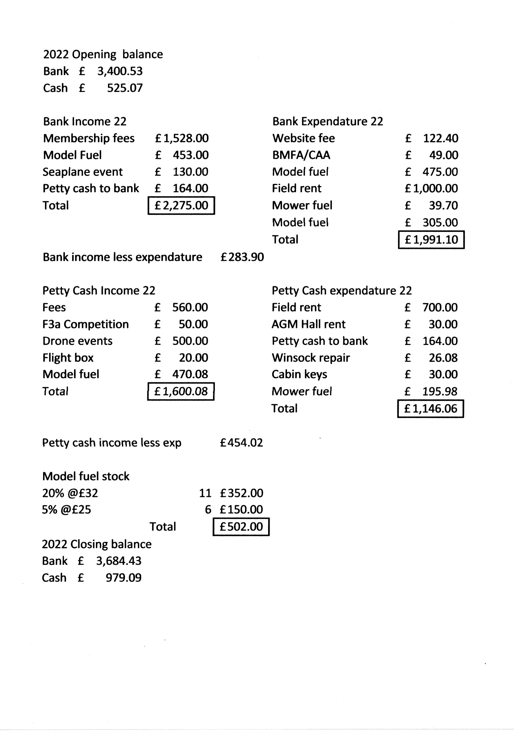
Annex A

